# **A Holistic Analytics Approach for Determining Effective Promotional Product Groupings**

Mehul Zawar, Siddharth Harisankar, Xuanming Hu, Rahul Raj, Vinitha Ravindran

Purdue University, Department of Management, 403 W. State Street, West Lafayette, IN 47907 mzawar@purdue.edu; sharisan@purdue.edu; hu661@purdue.edu; rajr@purdue.edu; ravindr1@purdue.edu

**Problem Statement**

Promotional grouping of products is an effective pricing strategy used across multiple industries such as retail, healthcare, and many more. Promotional product groupings (PPGs) or bundling can be seen everywhere, from value meals served at fast-food chains to the suite of tools sold by MS Office. The fact that the component products are readily available means that bundling is one of the most flexible elements of product strategy. Bundling is based upon the idea that customers usually save more on the value of the grouped package than the individual items when purchased separately. However, some caveats come with bundling, most of which stem from inadequate planning. Bundling could lead to the cannibalization of products that are not present in bundles. Furthermore, it could lead to customers not choosing to buy the desired product because they would have to buy the other product bundled with it. The study uses optimization to suggest an ideal bundling strategy that would maximize revenue.

**Why Optimization?**

The decision to select which products should form a bundle is dependent on numerous factors. One of the primary reasons for bundling is to give consumers the idea that they are in control. Consumers like to have choices, but they also prefer solutions that are usually bought together and fit their personal needs. Ideally, the products would be complementary to one another, which would enhance the customer experience. A detailed analysis would need to be conducted to understand which products are complementary. Furthermore, the consumer’s willingness to pay should be kept in mind. The price of the new PPG should not be too expensive that it drives consumers toward rival brands.

To incorporate the above requirements and develop PPGs that maximize revenue, an optimization model would be ideal. The model would adhere to the constraints discussed above and yields the best PPG recommendations in terms of revenue.

**Business Impact**

With companies across industries continually striving to get ahead of the competition, product pricing could be the deciding factor in driving or destroying the margins of a company. A detailed analysis of the client’s PPG strategy reveals that while leading the market in specific segments, they fall short in others. We aim to identify these areas of concern and examine how to improve their PPG sales and subsequently gain larger market shares.

Currently, the company generates product bundles based on human intuition, which is a flawed process. It is susceptible to human errors and biases in product selection. The recommendations generated via optimization would greatly simplify the company’s decision-making process. It provides a robust framework that considers historical data and can be modified as required.

**Goal**

The goal of the model is to identify new promotions groupings that can boost the Company’s sales.

**Objective Function**

The objective of the Optimization Solver is to maximize revenue. It is given by the following equation:

Max Z = $\sum_{i=1}^{n}{\left[Pi*Qi*Di*\left(1.1\right)\right]+\left[Pi*Qi*(1-Di)\right]}$

where, Z = Revenue

Pi = Price of each product in bundle

Qi = Quantity of each product in bundle

Di = Binary value. Indicates whether a specific product is present in bundle or not

**Decision Variables**

Optimization model was developed for each sub-category. Each unique product (SKU) is considered as an individual decision variable. Our aim is to find a combination of products that can be combined to form a bundle for promotion.

**Constraints**

***Number of products in a bundle:***

**2 ≤ n(Xi) ≤ 4**

There will be at least 2 distinct products in a PPG and at-most 4 distinct products in a PPG.

***Decision Variables can take only Binary Non-Negative values***

**Xi = {0,1}**

A product can be included in the bundle only once. This constraint ensures that no same products can be included in the bundle more than once.

***Price of the bundle***

$$\sum_{i=1}^{n}{P\left(X_{i}\right)}≤\frac{\sum_{j=1}^{N}{P\left(X_{j}\right)}}{N}*n\left(X_{i}\right)$$

The price of the bundle should not be too high. The sum of the price of individual products in the bundle should be less than the average price of all the products in the bundle multiplied by the total number of products in the bundle.

***Quantity Sold***

$$\sum_{i=1}^{n}{Q\left(X_{i}\right) *Corr(X_{i},n)}≥\frac{\sum_{j=1}^{N}{Q\left(X_{j}\right)}}{N}*2n\left(X_{i}\right)$$

Corr (Xi,n) refers to the Selling Correlation between two products. For example, if A & B are sold separately, quantities sold are x & y, respectively. However, if they are sold together, then the total quantity sold will be 1.1 * (x+y). The factor of 1.1 suggests that the products complement each other.

Due to the limited availability of data, the study has considered 10% as the correlation factor between any two products. A more accurate correlation factor can be computed using Market Basket Analysis if associations between products is known using the transaction data.

As per this constraint, the quantity sold for the formed PPG bundle should be more than the average sold quantities of products in the sub-category times the number of products in the bundle times 2. This will ensure that the quantities sold are higher through bundling.

***Revenue earned***

$$\sum_{i=1}^{n}{R\left(X_{i}\right)}≥\frac{\sum_{j=1}^{N}{R\left(X_{j}\right)}}{N}*2n\left(X_{i}\right)$$

Total revenue after optimization should be higher than the current cumulative revenue earned by all the products in the sub-category.

**Tool used for Optimization**

SAS was used to run optimization and obtain results. The code for the same can be viewed below:



**Results**

The optimization was conducted on one of the sub-categories, and the results for sanitizer is shown below:

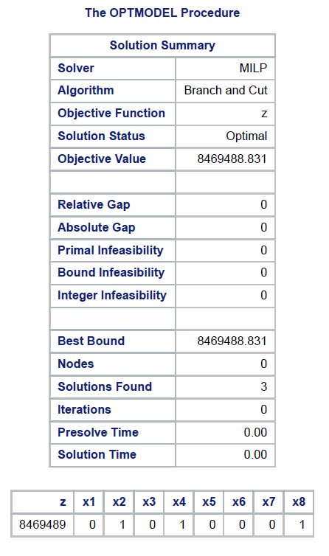

The decision variables considered are X2, X4 and X8 and revenue is maximized to $8.46M. The same analysis is repeated for Cleaning Wipes.

**Recommended Product Groupings**

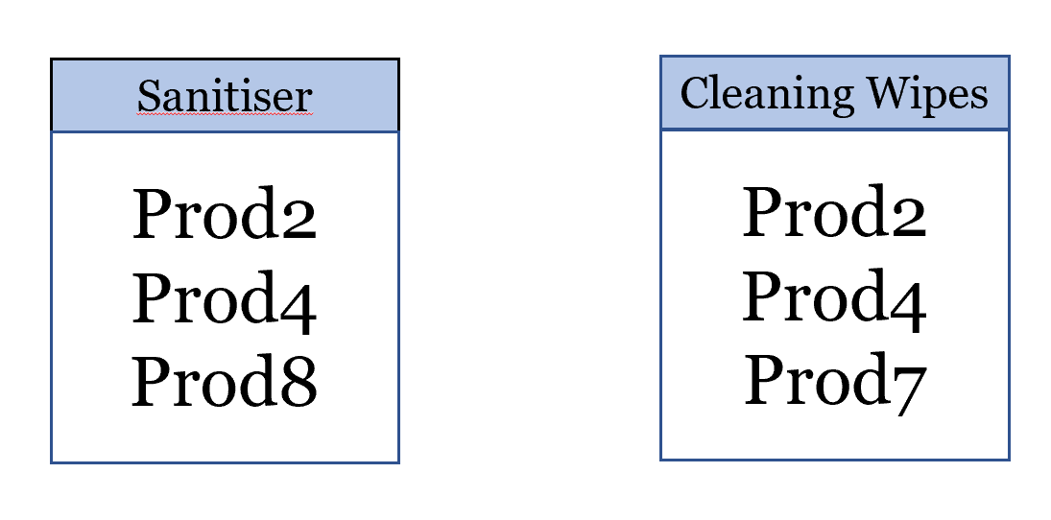

**Sub-Category Optimization Results**

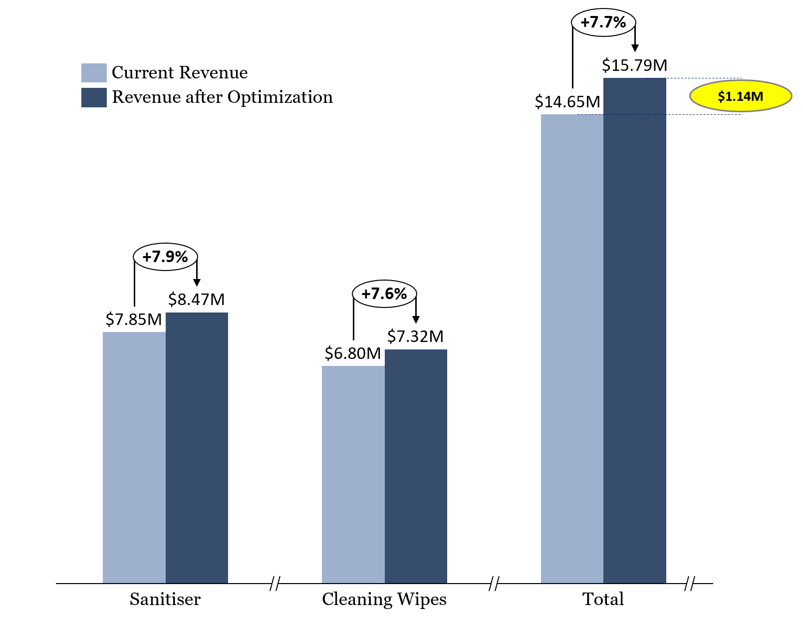

The Company has two categories, and the chart reflects the revenue generated before and after optimization. Using optimization, the study was able to increase the revenue of the Company by 7.7% per annum, which is tantamount to a $1.14 million growth in revenue.

**Excel Prototype**

The optimization is performed on Excel Solver to validate the analysis. Evolutionary algorithm is used for this model as global maxima is achieved. The results for Sanitiser are as below:

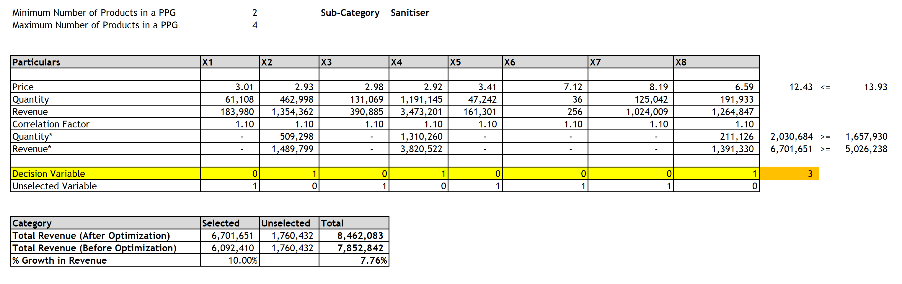

**Model Validation**

The results are validated for Sanitizer and Cleaning Wipes using Excel and SAS



**Conclusion and Future Scope**

Thus, we can conclude that the model on SAS gives the optimized revenue and it is validated with Excel Solver. The analysis can be further extended to enhance the optimization model if the below factors are considered:

* **Manufacturing Cost of Product –** We can calculate product margin, use it in the analysis and optimization to improve the model
* **Store wise analysis –** Analyzing transactions from individual stores to identify demographic data to provide personalized promotional recommendations to boost sales
* **Customer Transaction Analysis –** If we obtain transactional data of customer spending, we can use Market Basket Analysis to uncover associations between items